User Manual Document

New York Restaurant Inspection Results

Kartik Mathur(s5309927)

Manish Shrestha ( s5308120 )

Nivethaa Elangovan ( s5298899 )

Table of Contents

**1.** **INTRODUCTION** 3

1.1 Software Introduction 3

**2.** **SYSTEM REQUIREMENTS** 3

**3.** **RUNNING THE SOFTWARE** 3

**4.** **USER INTERFACE OVERVIEW** 3

4.1General UI 3

4.2 Home Page 4

4.3Dashboard Page 5

**5** **USING #VISUALISE** 5

5.1 Data Description 5

5.2 Filters 9

5.3 Plots 10

5.4 Messages 12

# **INTRODUCTION**

The document briefly describes the software analysis tool – ‘#Visualise’. It comprises instructions for deployment and usage instructions for the end users.

## 1.1 Software Introduction

The software aims to analyse and visualise the results of inspections conducted around various restaurants in New York. It allows users to view detailed data in a tabular format and gain insights into the data using various plots. Users are allowed to filter the data based on dates and keywords. In addition, the users are provided with an option to export the data to a CSV format.

# **SYSTEM REQUIREMENTS**

This section will list the softwares and the corresponding versions required to run the software.

|  |  |
| --- | --- |
| **Module / Software Name** | **Version** |
| python | 3.11 |
| pandas | 2.1.1 |
| numpy | 1.26.0 |
| matplotlib | 3.8.0 |
| wxPython | 4.2.1 |

# **RUNNING THE SOFTWARE**

The software can be run by executing the run_software.py file.

# **USER INTERFACE OVERVIEW**

The user interface of the software is designed in a way that is user-friendly, self-explanatory and compatible. This section gives a brief overview of the home page and the dashboard page.

## General UI

The general user interface comprises a header section, the body and a footer section. The header section consists of the logo ( product name ) and the footer section comprises the copyright information. The content of the body section varies depending on the page chosen as the software consists of two pages: 1) Home page and 2) Dashboard page. The user is provided with a navigation tab to toggle between the two pages. Active tab is shown in a violet shade and inactive tab is shown in grey shade.

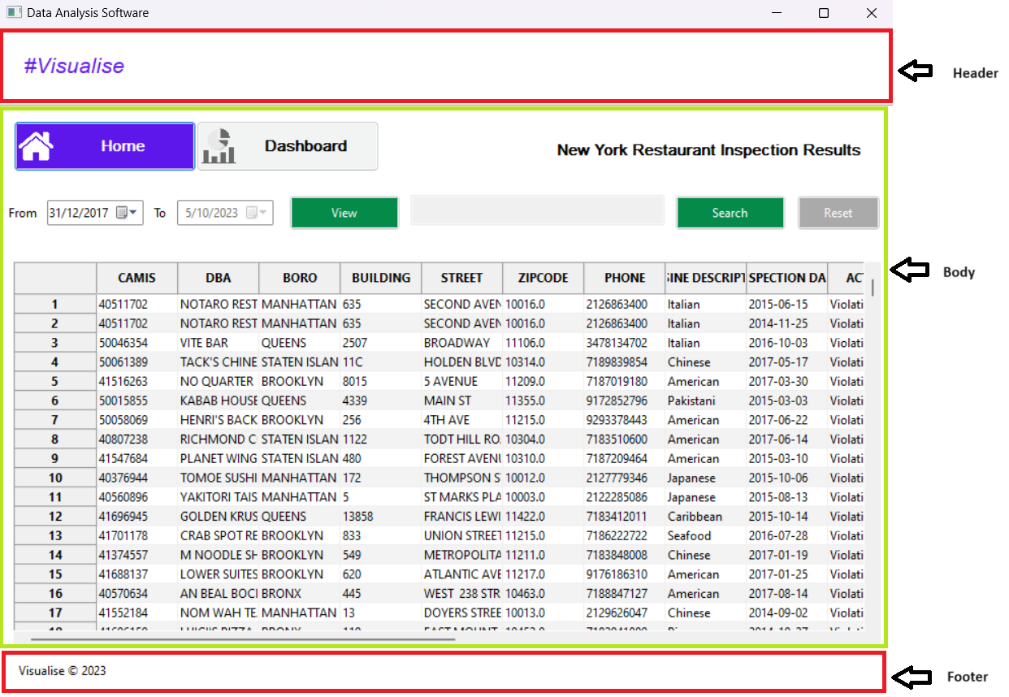

Figure General UI

## 4.2 Home Page

The home page consists of the data in a tabular format along with filters to extract data that the user wants to view. Individual columns in the table can be expanded to view data that overflows the existing column size. The user is provided with a horizontal and vertical scroll bar to view data.

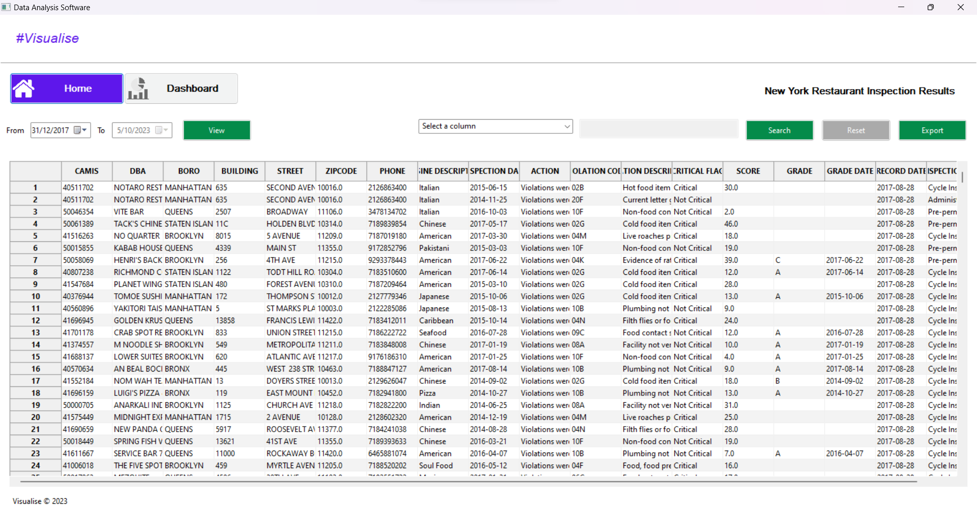

Figure Home Page

## Dashboard Page

The dashboard page visualizes various plots which provide the user with various insights to the data under analysis. Similar to the home page, the user is provided with date filters to select a date range for data extraction.

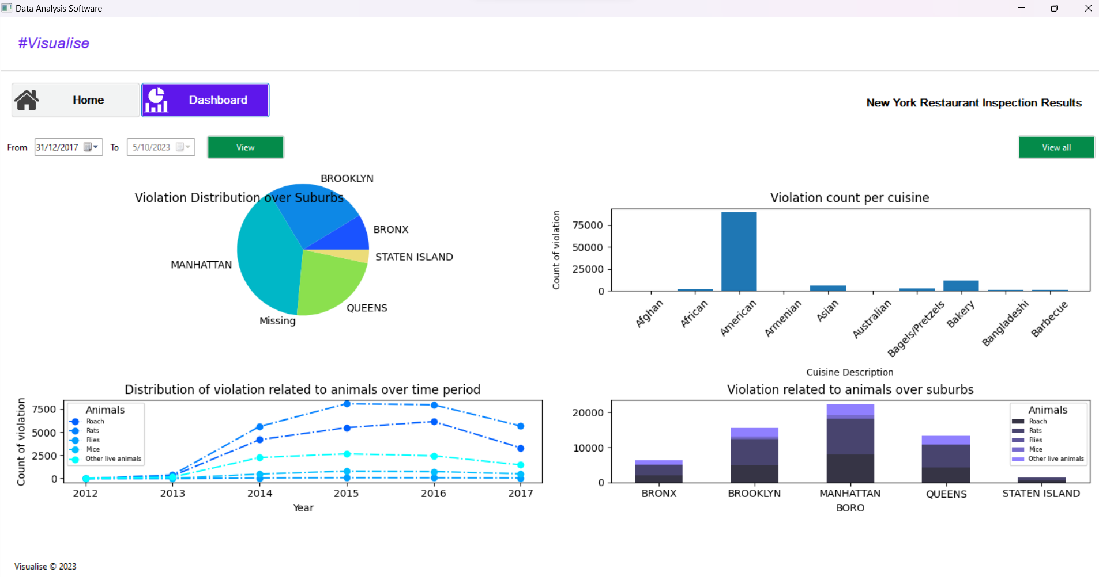

Figure Dashboard Page

# **USING #VISUALISE**

This section will describe in detail each feature of the software and will also include a detailed description of the dataset. When the user runs the software, the home page will be displayed initially and the user can toggle between the home and dashabord pages.

## 5.1 Data Description

This section gives a detailed description of the column names, expected values and a brief description of the column values.

|  |  |  |
| --- | --- | --- |
| **Data Field Name** | **Expected Values** | **Description** |
| CAMIS |  | This is a unique identifier for the entity (restaurant) |
| DBA |  | This field represents the name (doing business as) of the entity (restaurant) |
| BORO | • 1 = MANHATTAN • 2 = BRONX • 3 = BROOKLYN • 4 = QUEENS • 5 = STATEN ISLAND • Missing | Borough in which the entity (restaurant) is located. NOTE: There may be discrepancies between zip code and listed boro due to differences in an establishment's mailing address and physical location |
| BUILDING |  | This field represents the building number for the entity (restaurant) |
| STREET |  | This field represents the street name at which the entity (restaurant) is located. |
| ZIPCODE |  | Zip code as per the address of the entity (restaurant) |
| PHONE |  | Phone number |
| CUISINE DESCRIPTION |  | This field describes the entity (restaurant) cuisine. |
| INSPECTION DATE |  | This field represents the date of inspection. NOTE: Inspection dates of 1/1/1900 mean an establishment has not yet had an inspection |
| ACTION | • Violations were cited in the following area(s). • No violations were recorded at the time of this inspection. • Establishment re-opened by DOHMH • Establishment re-closed by DOHMH • Establishment Closed by DOHMH. Violations were cited in the following area(s) and those requiring immediate action were addressed. • "Missing" = not yet inspected | This field represents the action that is associated with each restaurant inspection. |
| VIOLATION CODE |  | This field represents each violation associated with a restaurant inspection. |
| VIOLATION DESCRIPTION |  | This field describes the violation codes |
| CRITICAL FLAG | • Critical • Not Critical • Not Applicable | Critical violations are those most likely to contribute to foodborne illness. |
| SCORE |  | Total score for a particular inspection; updated based on adjudication results. |
| GRADE | • Not Yet Graded • A = Grade A • B = Grade B • C = Grade C • Z = Grade Pending • P=Grade Pending issued on re-opening following an initial inspection that resulted in a closure | This field represents the grade associated with this inspection. Grades given during a reopening inspection are derived from the previous re-inspection. |
| GRADE DATE |  | The date when the grade was issued to the entity (restaurant) |
| RECORD DATE |  | The date when the webextract was run to produce this data set |
| INSPECTION TYPE | •Calorie Posting/ Compliance Inspection •Calorie Posting/Initial Inspection •Calorie Posting/ Re-Inspection •Calorie Posting/ Second Compliance Inspection •Cycle Inspection/Compliance Inspection •Cycle Inspection/Initial Inspection •Cycle Inspection/Re-Inspection •Cycle Inspection/Reopening Inspection •Cycle Inspection/Second Compliance Inspection •Inter-Agency Task Force/Initial Inspection •Inter-Agency Task Force/Re-Inspection •Pre-Permit (Non-operational)/ Compliance Inspection •Pre-Permit (Non-operational)/ Initial Inspection •Pre-Permit (Non-operational)/ Re-Inspection •Pre-Permit (Non-operational)/ Second Compliance Inspection •Pre-Permit(Operational)/Compliance Inspection •Pre-Permit(Operational)/Initial Inspection •Pre-Permit(Operational)/Re-Inspection •Pre-Permit(Operational)/Reopening Inspection •Pre-Permit(Operational)/Second Compliance Inspection •Smoke-Free Air Act/Complaint (Initial Inspection) •Smoke-Free Air Act/Compliance Inspection •Smoke-Free Air Act/Initial Inspection •Smoke-Free Air Act/Limited Inspection •Smoke-Free Air Act/Re-inspection •Smoke-Free Air Act/Second Compliance Inspection •Trans Fat/Compliance Inspection •Trans Fat/Initial Inspection •Trans Fat/Re-inspection •Trans Fat/Second Compliance Inspection | A combination of the inspection program and the type of inspection performed |

## 5.2 Filters

This section aims to explain the filters in the home and dashboard pages in detail.

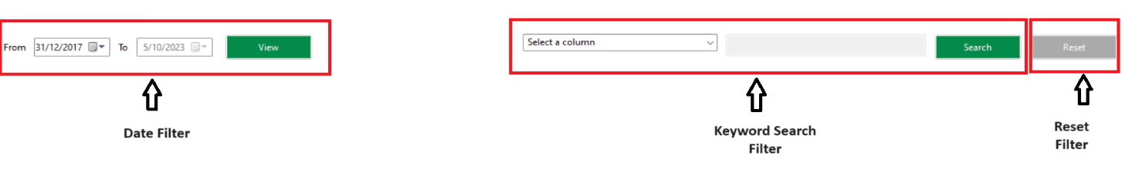

Figure Filter section

Figure 4 displays the filter section of the home page. It consists of the date filter where the user can choose a mininum date ( From ) and a maximum date ( To ) upon which the data is filtered. As described in the data description section, there are multiple columns with date values. But we filter data based on the column ‘INSPECTION DATE’ as it is crucial for the data analysed.

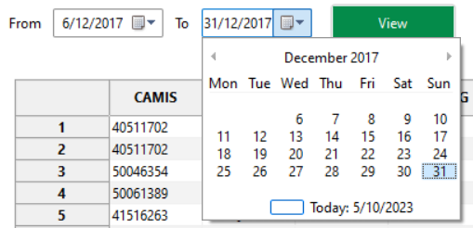

Figure Date Filter

Initially, the ‘To’ date field is disabled because the system does not allow the user to set a maximum date without choosing a minimum date. When the user selects a minimum date ( From ), the ‘To’ date field is enabled with a date range to choose from. Clicking on the view button will filter data based on the date range selected and rearrange the table values. If the date range does not contain any matching data, information will be displayed to the user stating the same.

The keyword search filter shown in figure 6 consists of a select field, text field and a search button.

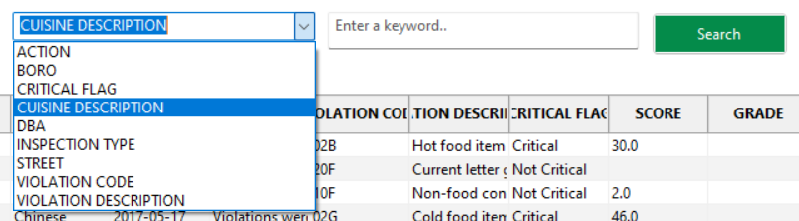

Figure Select and Keyword Search Field

The text field is disabled initially. When the user chooses a valid column name from the dropdown, the text field is enabled. Once the user enters text in the text field and clicks on the search button, the data is matched with the chosen column name and any rows that contain the keyword are displayed in the table. For an invalid match, an information is displayed to the user.

As shows in figure 4, the reset button will reset all the filters and load the initial data.

Figure Export button

The export button on the top right corner of the home page will export the data currently displayed in a CSV format.

The dashboard page contains the date filter which operates in a similar format as the home page and does not contain any other filters to view the plots.

## 5.3 Plots

The dashboard page consists of 4 major plots and a detailed plot. This section will describe the features of each plot in detail.

Figure Plot 1

Figure 8 shows the first plot visualised in the dashbaord page. The plot visualises the distribution of violation over different suburbs that were inspected.

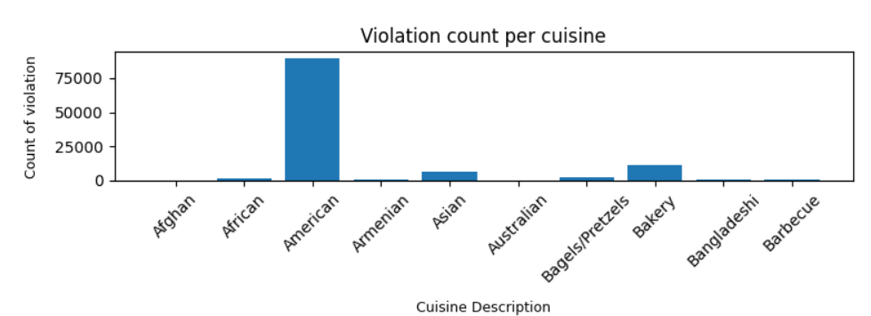

Figure Plot 2

Figrure 9 shows the second plot. This plot visualises the violation count across each cuisine. Since there are a variety of cuisines the top 10 cuisines are displayed sorted according to ascending order of the cuisine names.

Figure Plot 3

Figure 10 shows the third plot. This plot gives an insight on the count of violations related to animals over the period of years that the data was collected.

Figure Plot 4

Figure 11 shows the fourth plot. This plot is similar to the previous plot. But unlike the previous one, it visualises the count of violations related to animals over different suburbs

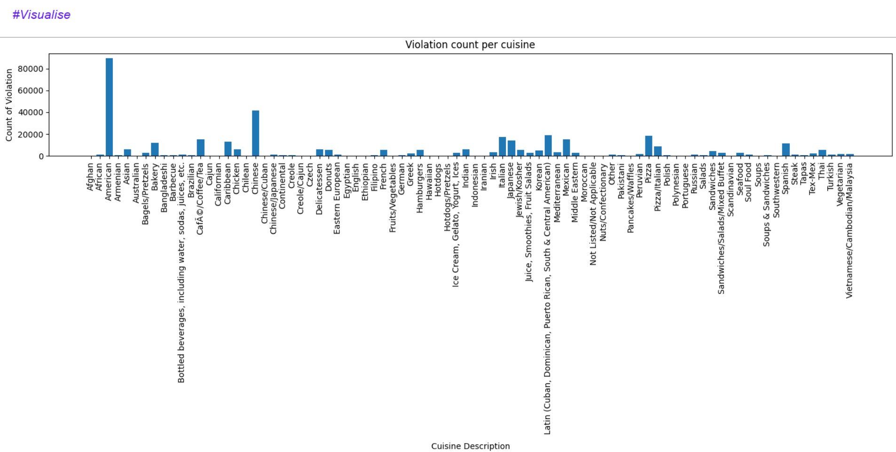

Figure Detailed Plot

Figure 12 shows the detailed visualisation of the second plot. When the user clicks on the view all button on the top right corner of the dashboard page, a new window displays the detailed plot. It is a static page, hence the user will not be able to perform any filter actions on the plot.

## 5.4 Messages

The software provides the user with a number of informative and warning messages which makes it easy for the user to understand the condition under which the operations are performed. This section details the messages and the scenrios in which they appear.

|  |  |  |
| --- | --- | --- |
| **Scenario** | **Message Type** | **Message** |
| The user selects a date range and no data is available for the selected date range | Info | No data available for the selected date range |
| The user attempts to delete the column values in the select field or enters an invalid column name | Info | Please choose a column from the dropdown |
| The user enters a keyword and there is no valid data matched for the keyword | Info | No data match for <keyword> |
| The user hits the search button without entering a keyword in the text field | Info | Please enter a keyword to search |
| The user clicks on the export button and the data is exported successfully | Info | Data exported successfully!! |